Not sure how to draw a capital letter? See page XX.!
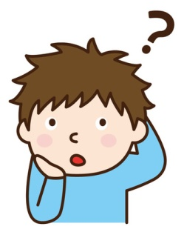

Tick the words that should start with a capital letter, then write them out correctly:

fresh

thursday

better

night

sahara desert

bakery

friendly

jamie

wash

portugal

tomorrow

nokia

edinburgh

television

norwegian

desert

tommy’s bakery

normal

june

grapes

forget

reebok

necessary

autumn

