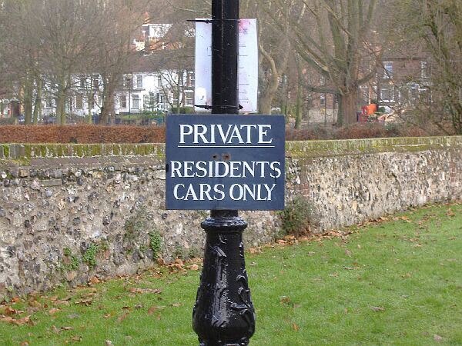

Answer:

There should be a possessive apostrophe after “RESIDENTS” to show that the cars belong to them. The sign should read: “PRIVATE. RESIDENTS’ CARS ONLY”.

